Services for Singapore & APAC Businesses
GS ConsultPro provides integrated digital marketing, SEO, web development, and growth solutions for Singapore businesses and companies across APAC, helping brands increase visibility, generate demand, and drive sustainable revenue growth.

SEO
From technical audits to semantic content networks, our SEO service builds lasting organic authority, reducing customer acquisition costs and compounding search visibility on Google.
WEB DESIGN & DEVELOPMENT
Conversion-optimised, technically sound websites designed for strong Core Web Vitals performance, scalable architecture, and high-performing lead generation infrastructure.

MOBILE APP DEVELOPMENT
Native and cross-platform mobile applications built for performance, scalability, and seamless user experiences on iOS and Android.

SALES AUTOMATION & GROWTH SYSTEMS
Sales automation systems and growth workflows designed to streamline follow-up, improve response times, and support stronger conversion throughout the customer journey.

CONTENT CREATION
Strategic content that builds authority, engages your audience, and drives organic growth across websites, blogs, social media, and campaigns.

DIGITAL ADVERTISING & SOCIAL MEDIA
Precision-targeted Google Ads and social media campaigns across Meta, LinkedIn, and TikTok, designed to increase brand visibility, enhance audience engagement, and support business growth objectives.

I have added more services.
It is better I think to group them into broad categories rather than simply listing them.
Growth & Marketing
- SEO
- Content Creation
- Digital Advertising & Social Media
- Demand Generation & Pipeline Growth
- Sales Automation & Growth Systems
Digital Experience
- Web Design & Development
- AI Video Development & Production
- Mobile App Development
Strategy & Engagement
- Partnership Strategy & Ecosystem Development
- Industry Events & Executive Roundtables
- Corporate Training & Workshops

More Than Marketing. Built for Growth.
(minor changes here)
Businesses work with GS ConsultPRO because we combine regional insight with structured strategy and execution. We move beyond isolated campaigns, aligning marketing, digital experiences, and growth initiatives with clear business objectives to support sustainable growth across Singapore and APAC.

Decisions Backed by Real Data
(minor changes below)
Every decision is grounded in real market data and customer behaviour. We analyse demand, user intent, and competition to identify opportunities and support measurable growth using platforms such as Google Analytics, SEMrush, and Ahrefs.

All sections were ending in Singapore and APAC, so minor changes again.

Financial Services & Fintech
We work with financial services and fintech companies to build trust in regulated markets, strengthen market positioning, and support sustainable growth.
SaaS & Technology
We work with SaaS and technology companies to drive product adoption, strengthen positioning, and scale effectively across regional markets.
Professional Services
We work with professional services firms to build authority, generate high-value demand, and support long-term business growth.

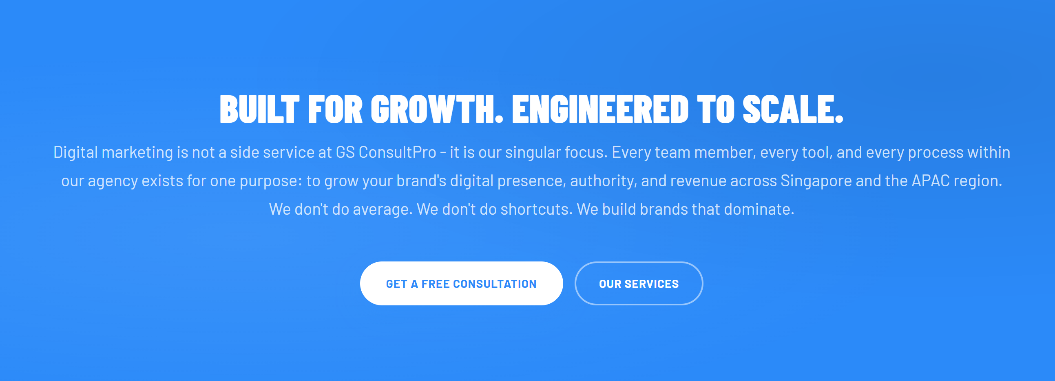
The text above needs to change as we are saying above that we are doing more than marketing.

Change like below:
GS ConsultPRO combines digital marketing, growth strategy, digital platforms, automation, and market engagement solutions to help businesses strengthen visibility, generate demand, and support scalable growth across Singapore and APAC.
From SEO and content strategy to web development, partnership strategy, AI-powered video production, and executive engagement initiatives, every solution is aligned with clear business objectives and measurable outcomes.
Strategy-led. Growth-focused. Execution-driven.

